LOCAL SEO

http://www.bingplaces.com/
http://foursquare.com/ | Done (Phone Verification Required) | 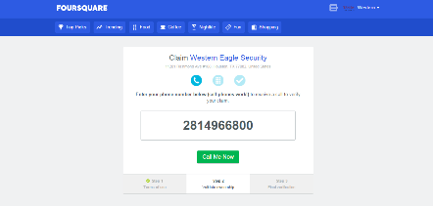
http://tomtom.com/en_us/ |  | Listed with errors  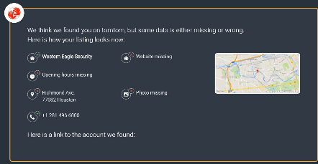
http://tripadvisor.com/ | Done | 
http://www.yellowpages.com/ | Already Submitted | 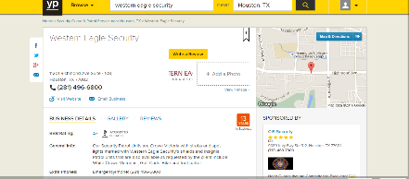http://www.yellowpages.com/houston-tx/mip/western-eagle-security-102030?lid=102030
http://here.com/ | Done | 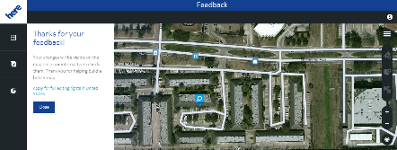
http://www.yalwa.com/ |  | 
http://www.superpages.com/
http://www.showmelocal.com/profile.aspx?bid=15099557 |  | 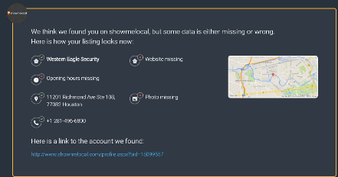  Listed with errors
http://www.elocal.com/ |  | Listed with errors  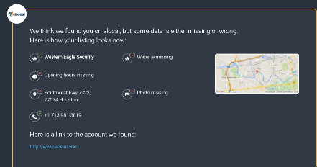
http://www.merchantcircle.com/western-eagle-security-houston-tx |  | Listed with errors  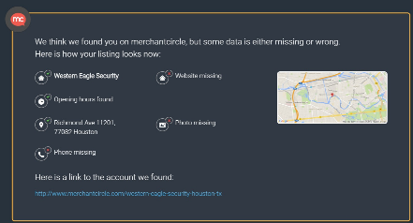
http://www.2findlocal.com/western-eagle-security-houston-tx.html |  | Listed with errors  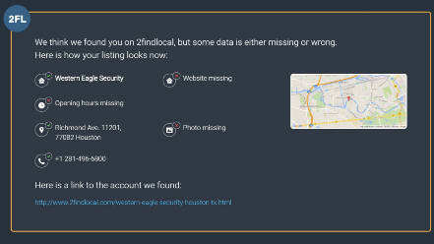
http://leads.infousa.com/Landing/UpdateListing.aspx?bas_vendor=99862 | Not Listing Site
http://www.manta.com/c/mml828b/western-eagle-security |  | Listed with errors  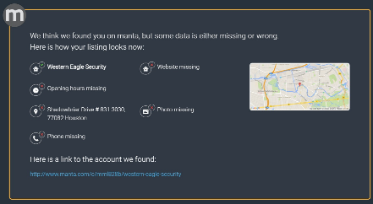
http://ezlocal.com/tx/houston/business/688609237 |  | 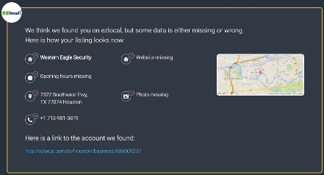Listed with errors
http://www.brownbook.net/
http://www.citysquares.com/b/western-eagle-security-12537731 |  | Listed with errors  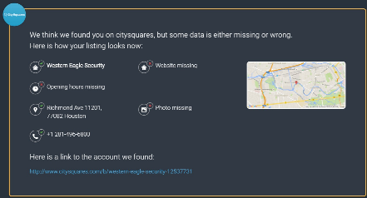
http://kudzu.com/ | Done | 
http://tupalo.com/ | Already Done | http://www.tupalo.co/houston-texas/western-eagle-security
http://www.myhuckleberry.com/ | Done | 
http://appleid.apple.com/
http://www.yahoo.com/
http://www.hotfrog.com/ | Done | http://www.hotfrog.com/business/tx/houston/western-eagle-security_41817522
http://businessdirectory.bizjournals.com/ | Done | 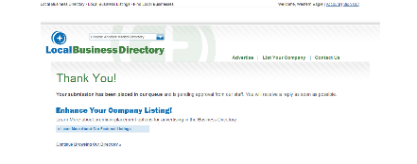
http://thumbtack.com/ | Reviews Required | 
http://www.magicyellow.com/ | Already Done | 
https://www.discoverourtown.com/ | Done | 
http://www.infignos.com/addlisting/speedlist.cfm | Done
http://www.databyacxiom.com/ | Error | 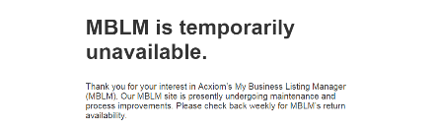

OFF Page

http://www.thesecurityguard.net/ | Not Listing Site
http://www.securityjobcentral.com/ | Not Listing Site
http://www.security-directory.com.au/ | Reciprocal Issue
http://www.ypdeals.com/ | Already Done | http://www.ypdeals.com/houston-tx/mip/western-eagle-security-102030?lid=102030
http://www.vanessagallant.com/ | Not Listing Site
http://www.urljc.com/ | Not Listing Site
http://www.tuffclassified.com/ | Not Listing Site
http://www.tourmodule.com/ | Not Listing Site
http://www.tmscene.com/ | Not Listing Site
http://www.timetoast.com/ | Not Listing Site
http://www.thunts.com/ | No Site
http://www.thegreensheet.com/ | Not Listing Site
http://www.tel-numbers.com/ | No Site
http://www.spiinnovations.com/ | Not Listing Site
http://www.shieldlab.com/ | Not Listing Site

